Joshua Furtado

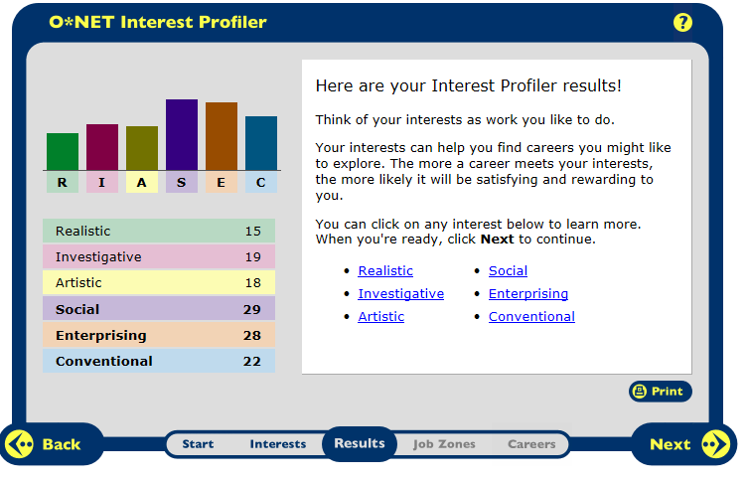
I agree with the scores presented to me. The reason for this is that I have loved helping since I was little and would love to be a counselor or teacher. Another thing is I also love enterprising. I love debates so I strive to be a lawyer, and I also like to keep track of money so it does not go to the wrong place. The only thing I do not agree with is that I would like to do more investigative work than conventional work. I like to use ideas to make projects better than what they are with specific directions.
Enterprising: Lawyer, Tax Collector, insurance Manager.
Social: Probation Officer, Family Counselor.
Conventional: Bill and Account Collector, Financial Analyst.

HR1: A lawyer either defends or prosecutes a suspect for a crime. Whether it is for a parking ticket or murder. A tax collector collects taxes from people.
An insurance manager is someone who tries to sell insurance products to buyers. A probation officer is someone who keeps an eye on people who have committed crimes and were released, if that person were to commit another crime, their probation officer would determine a punishment for them.
A family counselor is a counselor who worries on helping a family instead of one person.
A bill and account collector is someone who makes sure that people who have to pay their bills pay them otherwise they will contact law enforcement.
A financial analyst is someone who keeps track of people financial issues and tires of resolve them.
HR2: Some of the occupational fields for lawyers are criminal law attorneys and defense attorneys. Occupations for tax collectors are local tax collectors, state tax collectors, or government tax collectors.
The job for insurance managers is to manage a branch or part of an insurance company.
For probation officers you usually would work for either a court or a small company in the city/county.
A family counselor works for a company, hospital, or themselves. Bill and account collector works for a company that normally sends out bills that their customers must pay.
Like most of the other jobs, a financial analyst will work for a company, themselves, or a local, state, or national bank.
HR3: the personality type for the jobs that I am looking for is someone with hospitality to ensure their customer stays with the company.
HR4: The training/ learning period I have to undergo for all of these jobs is at least a bachelor’s degree.
HR5: the technology experience would have to be high since I would be storing info into databases and typing up documents for the people I am working for.
RC1: A lawyer would earn around $113,000 a year.
A tax collector earns around $50,000 a year.
An insurance manager would earn around $104,000 a year.
A probation officer earns $47,000 a year.
A family counselor earns $54,000 a year.
A bill and account collector would usually earn $20,000 dollars a year.
A financial analyst makes $75,000 a year.
RC2: Lawyers are going to be needed more, as will financial analysts and insurance managers. Tax collectors will not need many more.
Probation officers will need more but not many more. Family Counselors will be needed more in the following years.
Bill and account collectors are needed but not many of them.
RC3: Family Counselor-American Mental Health Association, and American Counselors Association.
Probation officer- American Probation and Parole Association.
Lawyer- National Association for Law Placement, and Law School Admission Counsel.
Tax Collector- Internal Revenue Service.
Insurance Manager- Financial Management Association International.
Bill and account collector- The Association of Accountants.
Financial Analyst- American Academy of Financial Management.
ISC1: The environments for these jobs are mostly in offices or meeting people other places. The work hours are either when I am needed or during a normal 9-5.
ISC2: The careers I have are not mostly in a Union, although there could be some in private businesses.
ISC3: There are chances for promotion in all of these careers.
All the job choices I have made are available at these colleges:
Adelphi University, Bridgewater State University, and UMASS Dartmouth.

Occupation | Income per Year
Lawyer | $113,000
Tax collector | $50,000
Insurance manager | $104,000
Probation Officer | $47,000
Tech. Exp. | Colleges | Learning Period
High | UMASS Dart. | Bachelor’s degree/ 4 years of law
High | Adelphi Uni. | 4 years of college
High | Adelphi Uni. | 4 years of college
High | Bridgewater. | 4 years of

Occupation | Income Per Year
Family Counselor | $54,000
Bill Collector | $20,000
Account Collector | $20,000
Financial Analyst | $75,000
Tech Experience | Colleges | Learning Period
High | UMASS Dartmouth | Doctorates Degree
High | Adelphi Uni. | Bachelor’s Degree
High | Bridgewater St. | Bachelor’s Degree
high | Adelphi Uni. | Bachelor’s Degree

Promotion | Work Envirnment | Unions | Tech. Experience | Work Fields
Possible | Office | National Association for Law Placement | High | Private or Public Lawyer
Possible | Office | - Internal Revenue Service | High | Local or State Tax Collector
Very Possible | Office | Financial Management Association International. | High | Head of a part or branch of Insurance Company
Not Common | Office | - American Probation and Parole Association | High | Public or Private Parole Officer
Not Common | Office | -American Mental Health Association | High | Family Counselor for Company or Self
Not Usual | Office | The Association of Accountants | High | Works for a company that normally sends out bills that their customers must pay.
Possible | Office | The Association of Accountants | High | Works for a company that normally sends out bills that their customers must pay.
Very Possible | Office | American Academy of Financial Management. | High | work for a company, themselves, or a local, state, or national bank.

